dataset_clean.csv — Differences from the Original & Non-Unicorn Profile
Cornell Capstone Project • dataset_clean.csv (n = 2,046: 1063 unicorns + 983 non-unicorns)
A teammate prepared dataset_clean.csv to support a supervised prediction task. This document first explains how it differs from the original Unicorn_Companies.csv and the reasoning behind those changes (Section 1), then profiles the non-unicorn companies it adds (Section 2). Each chart and table is followed by a short "What this means" note.

Section 1 — How dataset_clean Differs from the Original (and Why)
dataset_clean.csv is a reshaping of the original data for a prediction task. 9 unicorns are dropping because they are not considered as startup. Most of the changes are about structure and scope, not about altering unicorn facts.

1.1 Structure at a Glance
 | Original (Unicorn_Companies) | dataset_clean
Rows | 1,074 (all unicorns) | 2,046 (1,063 unicorns + 983 non-unicorns)
Columns | 10 | 9
Label | none | is_unicorn (1/0)

1.2 Columns Removed — and the Reasoning
Three columns from the original were intentionally dropped. For a model that predicts whether a company is a unicorn, each of these would leak the answer or be unavailable for non-unicorns, so removing them is sound preparation:
Removed Column | Why It Was Removed
Valuation | A unicorn is defined as valuation ≥ $1B, so it is effectively the answer itself — keeping it would be target leakage.
Date Joined | The date a company became a unicorn exists only for unicorns; non-unicorns have no such date.
Select Investors | Free-text investor lists are hard to use as a model feature and are not consistently available for smaller companies.
What this means — Removing these columns was a deliberate, reasonable choice for a prediction setup, not an oversight. The trade-off is that Date Joined and Select Investors were useful for descriptive work (they powered our timeline and investor analyses on the original data), so those angles are simply not available in dataset_clean.

1.3 Columns & Rows Added
- is_unicorn — the 1/0 label that turns the data into a supervised learning problem.
- Description — a short text blurb per company (present for most non-unicorns; often blank for unicorns, which were carried over from the original).
- Funding_USD — the original "$8B"-style funding strings converted to clean numeric USD.
- 983 non-unicorn companies — the negative class needed for supervised learning.
- Note: 9 pre-1995 unicorns from the original (e.g. Otto Bock HealthCare, founded 1919) were not carried over, so both classes now start in 1995 — a reasonable trimming of non-startup legacy firms.
What this means — In short, dataset_clean keeps the original unicorn facts, drops fields that do not fit a prediction task, converts funding to a usable numeric form, and adds a negative class. The genuinely new material is the 983 non-unicorn companies, profiled next.

Section 2 — Descriptive Analysis of the Non-Unicorn Companies
The 983 non-unicorn companies are private firms that had not reached $1B valuation. This section describes who they are and how they compare with the unicorn group.

2.1 Geographic Distribution
Continent | Companies | Share
North America | 642 | 65.3%
Europe | 145 | 14.8%
Other | 96 | 9.8%
Asia | 61 | 6.2%
Oceania | 18 | 1.8%
South America | 18 | 1.8%
Africa | 3 | 0.3%
Top countries: United States (607), United Kingdom (53), Canada (33), Israel (20), India (18). (96 companies are recorded as continent "Other" and 72 have no country listed.)
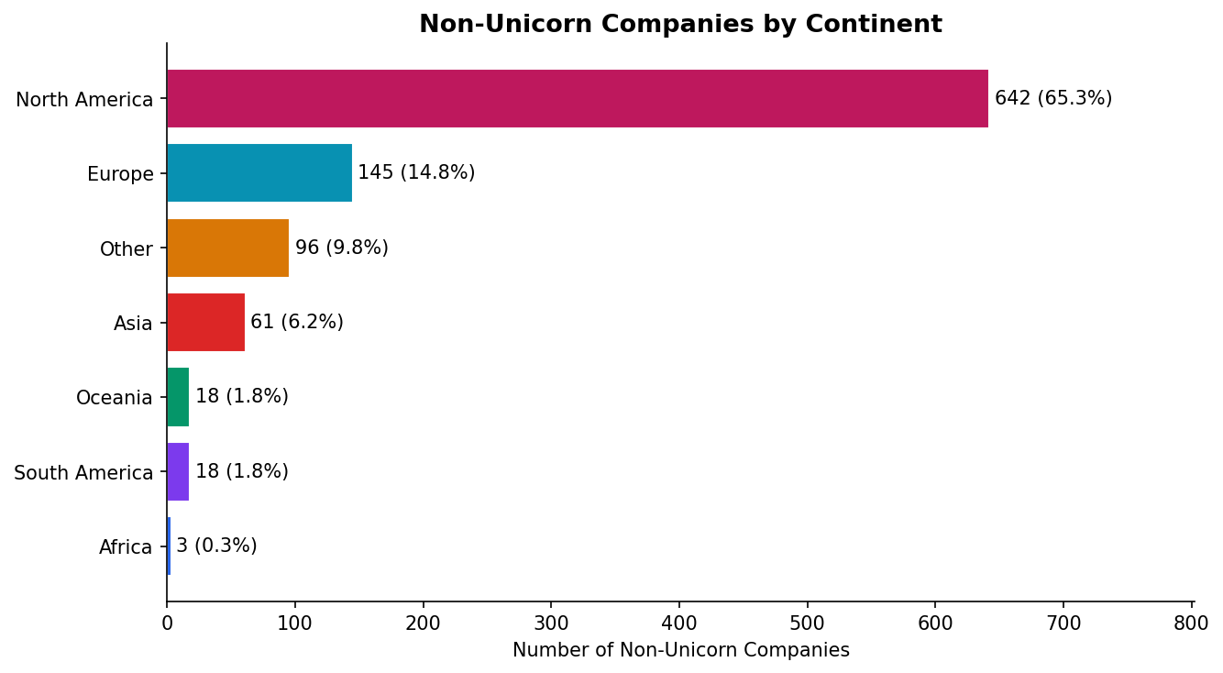
What this means — The non-unicorn set leans more heavily toward North America (65%) than the unicorn population does (55%). It reflects wherever this particular list was sourced, so it is best read as a sample of companies rather than a global census.

2.2 Industry Distribution
Industry | Companies | Share
internet software & services | 364 | 37.0%
other | 135 | 13.7%
mobile & telecommunications | 100 | 10.2%
health | 83 | 8.4%
e-commerce & direct-to-consumer | 77 | 7.8%
consumer & retail | 52 | 5.3%
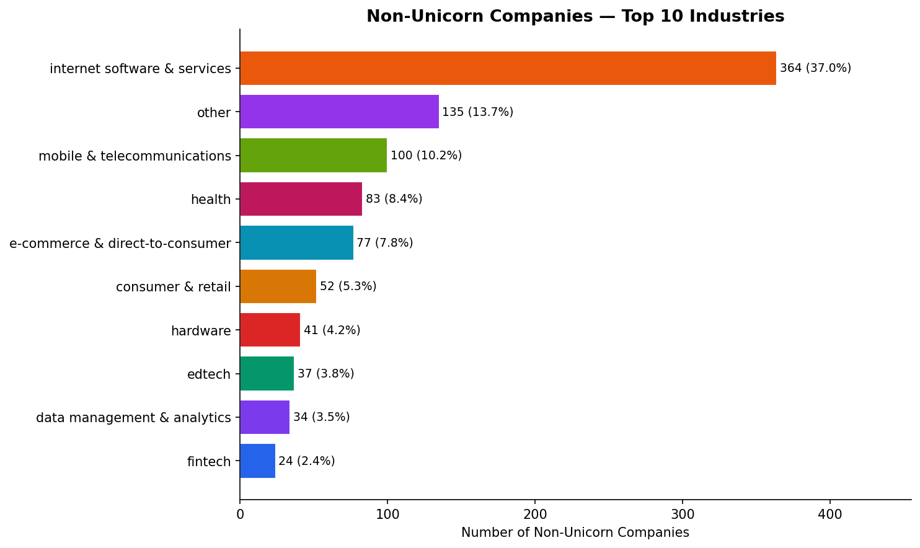
What this means — Internet Software & Services is the largest category at 37%, an even heavier share than among unicorns (19%). The negative class is concentrated in software companies, which is useful context when comparing the two groups by sector.

2.3 Funding Distribution
Median funding among non-unicorns is $0.75M, compared with $370M for unicorns.
Funding Band | Companies | Share
< $1M | 565 | 57.5%
$1-10M | 300 | 30.5%
$10-50M | 103 | 10.5%
$50-100M | 8 | 0.8%
$100M+ | 7 | 0.7%
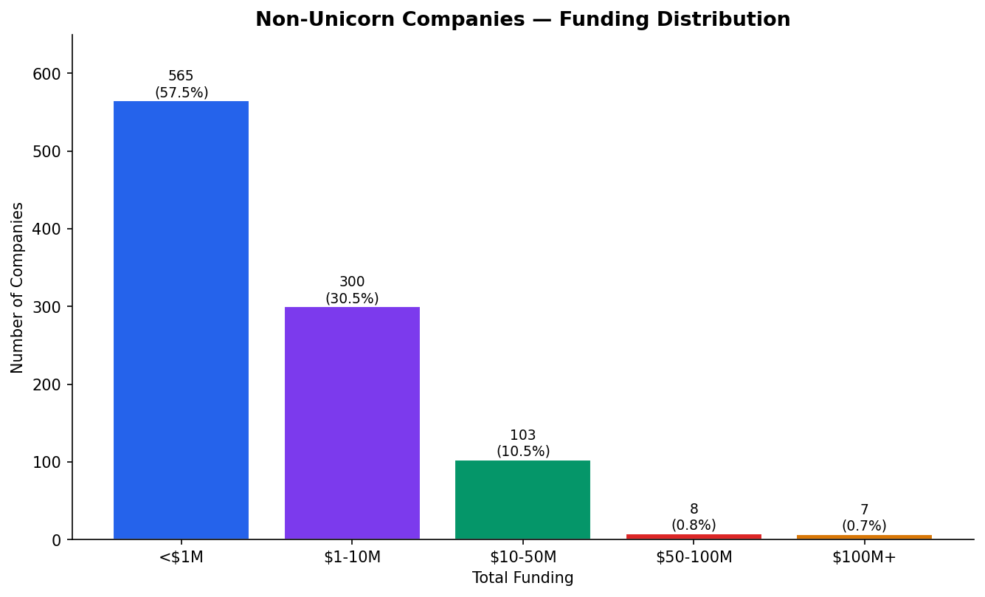
What this means — The non-unicorns are mostly earlier-stage or smaller companies — 88% raised under $10M. This is the clearest structural difference between the two groups: unicorns cluster at much larger funding levels.

2.4 Funding by Class
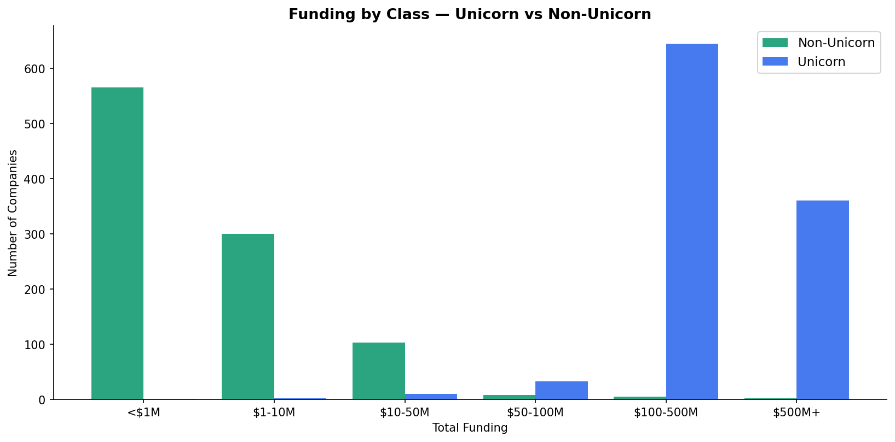
What this means — Placed side by side, the two groups occupy largely different funding ranges, with limited overlap in the middle. Funding is therefore the dimension that most clearly distinguishes the classes in this dataset.

2.5 Founding Year
Non-unicorn founding years range 1995–2014 (median 2012); the count peaks around 2013. The unicorn group extends further, through 2021.
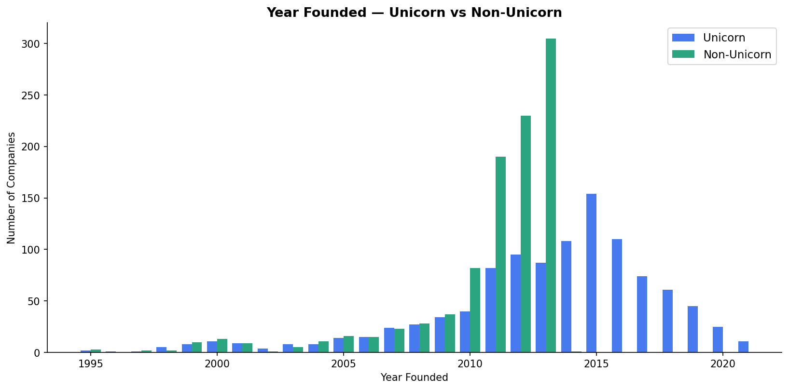
What this means — The two groups cover somewhat different time windows — the non-unicorns were collected mostly up to the early 2010s, while unicorns continue to 2021. Worth keeping in mind when comparing the groups, so that founding year is not mistaken for a difference in company quality.

Closing Note
dataset_clean.csv is a sensible, prediction-oriented reshaping of the original data: unicorn facts are preserved, leakage-prone columns were removed on purpose, funding was made numeric, and a non-unicorn class was added. The main practical differences between the two groups — funding scale and time window — are natural consequences of how each set was assembled, and are simply useful to keep in mind for any later modeling.

